Member Management

**Low Level Design Document**

Contents

1. ModuleName:Member management 3

1.1 Member Registration 3

1.1.1 Responsibilities 3

• Verify Email 3

• Generate Token 3

• Validate Token 3

• Create Member 3

1.1.2 Data Structure 3

• Member Credentials 3

o Attributes 3

▪ Email(string) 3

• OTP 3

o Attributes 3

▪ EmailId(string) 3

▪ OTP(string) 3

▪ GeneratedOn(DateTime) 3

1.1.3 Class Design 3

1.1.4 Interface Design 3

1.1.5 Error Handling 3

1.1.6 Security Considerations 3

1.1.7 Database Schema 4

1.1.8 Flow Diagram 4

1.2 Profile Management 4

1. ModuleName:Member management
   1. Member Registration
      1. Responsibilities

* Verify Email
* Generate Token
* Validate Token
* Create Member
  + 1. Class Design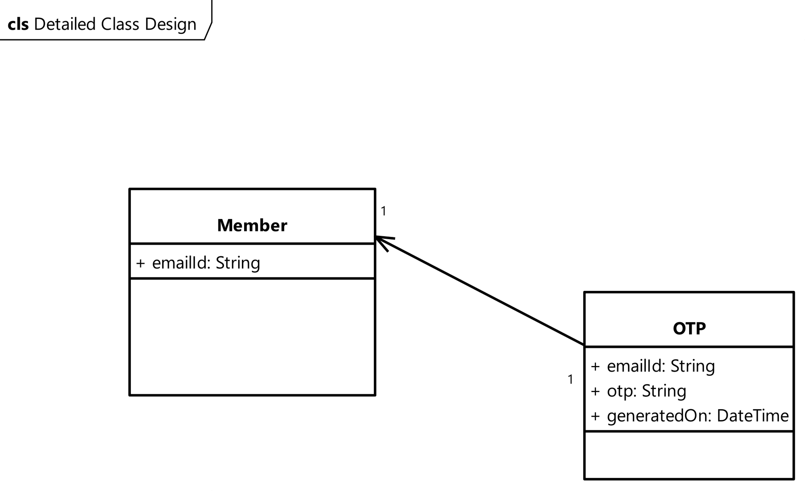
    2. Flow Diagram
    3. Interface Design
    4. Error Handling
    5. Security Considerations
    6. Database Schema
  1. Profile Management